|  |  |
| --- | --- |
| **Project Title** | **BookScape Explorer** |

**Project Summary:**

The BookScape Explorer project involves the development of Streamlit app to dynamically extract data related to books from Google API ,store the extracted results in MySQL Database and also retrieve data from the database.

**Tools & IDE Used :**

1. MYSQL 8.0
2. Visual Studio code 1.96 (IDE for python)

**Application Functionality Description:**

The developed app has a webpage titled “The Book Store” with side bar navigation to Book Search & FAQ sections. The default section is the Book Search. In the Book Search section , User has the option to enter the category related to which they need the books. On clicking the search button ,app extracts or collects 500 books related to the category entered from google API ,stores the collected data in MySQL database and displays the stored data in a table format.

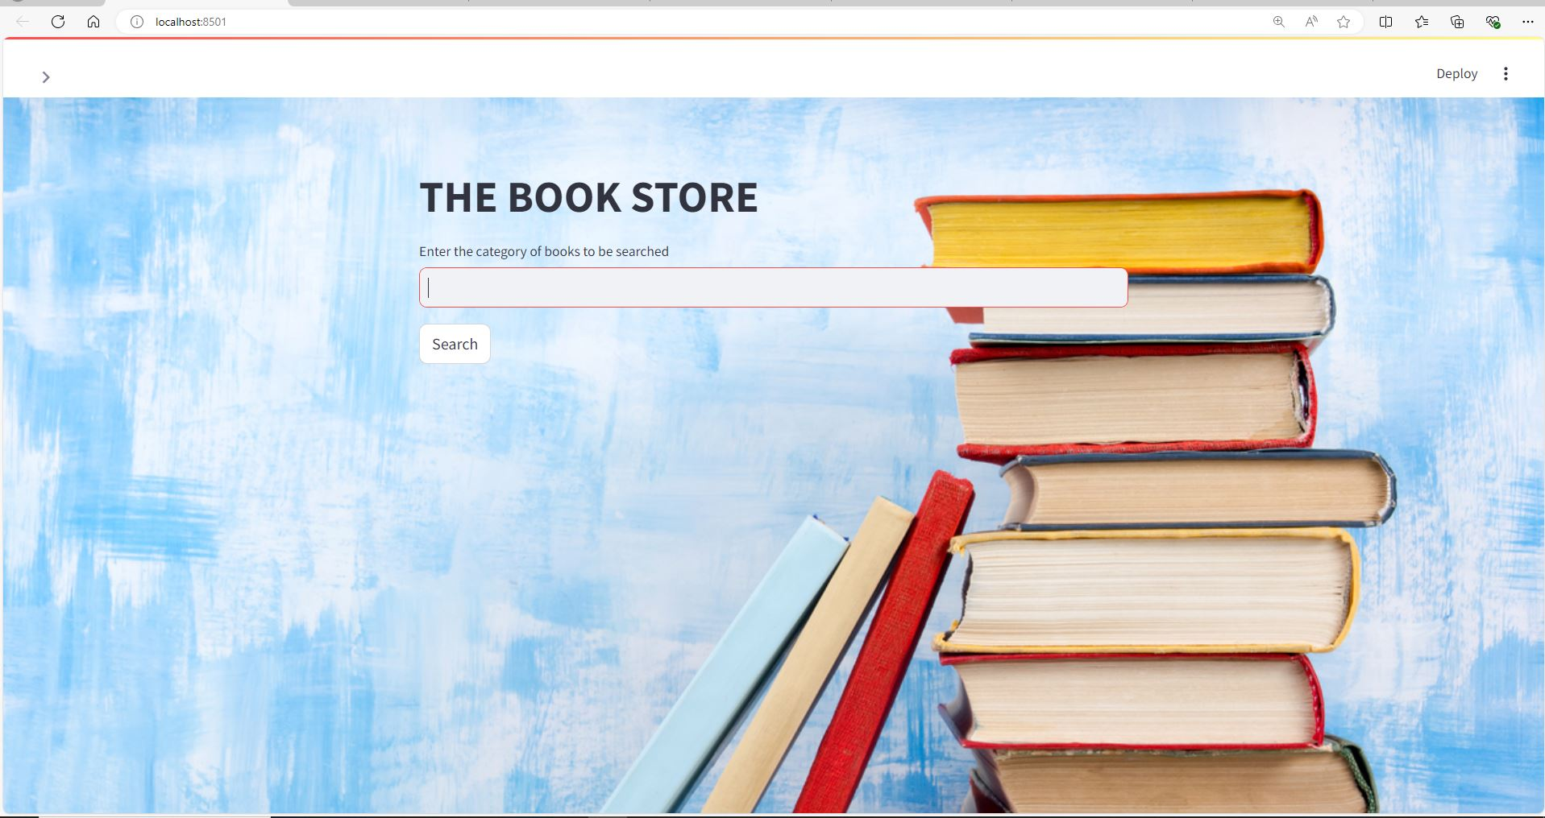

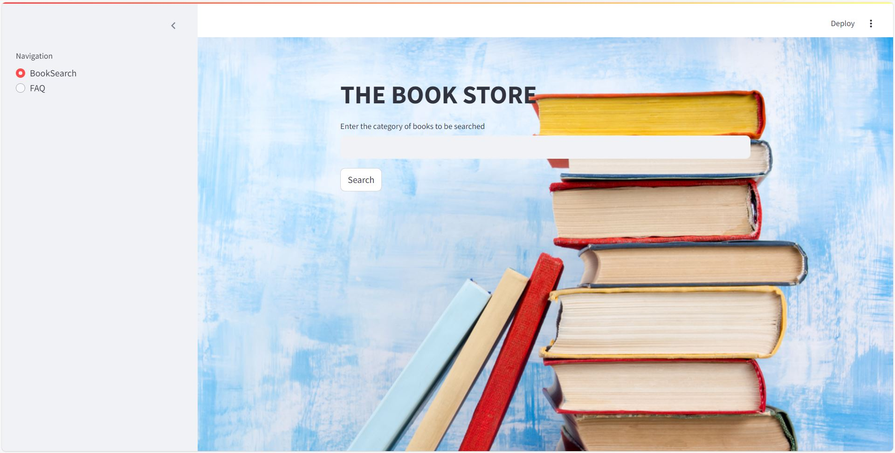

The FAQ section has a drop down to select from 20 commonly asked questions. The user can select the needed query & click on “Go” button to extract the relevant data from the database. On clicking the Go button, SQL queries are executed to retrieve data from database & it is displayed in a table format in the app.

**Backend Code Explanation:**

The code invloves the use of 3 main python libraries Streamlit for developing the application,pymysql for connecting python & mysql & pandas for converting the extracted data to a dataframe.The code utilises two user defined functions for data extraction.”extract_data” function is used to get json data from the google API and “extract_data_from_json” is used to convert the json data to a dataframe for inserting into the SQL Database. A very basic streamlit app is developed with Sidebar giving navigation to 2 sections & connection to mysql database is established using connect method of “pymysql” library.The SQL Queries are executed with the help of Cursor method & the results of same are displayed as a dataframe wirhin the app.

**Challenges Faced:**

1.One of the challenges wa establishing the MySQL Connection, initially this was tried using the mysql-python-connector library , but the version of mysql didn’t support thisdue to which pymysql library was used.

2.Another Challenge was in figuring out the right SQL Syntax for few queries & also handling the NA values in the SQL Dtabase.

3.One more challenge was in setting the background image , initially when using div style , background image was only getting for a second & then changing ,later had to use base64 for converting the image & then inserting.

.